
NAME : BISMA FATIMA
CLASS : CS A
ROLL NO: F24605036
COURSE : COMPUTER NETWORK
COURSE CODE : CS-271
LECTURER : SIR NAVEED YOUSAF

LAB 10

Configuration of DHCP in VLANs
Warm up Task [30 Minutes]
- Answer each question in your own words (3 to 4 lines)
1. What is VAN?
- VAN (Value-Added Network) is a private network provider that offers specialized services beyond basic data transmission.
- It acts as an intermediary between businesses, often used for secure Electronic Data Interchange (EDI), providing services like encryption, message routing, and auditing.
- Think of it as a managed communication service that adds reliability and security compared to using the public internet.
2. How are VLAN identified?
- VLANs are identified by a VLAN ID, which is a numerical value assigned to each VLAN.
- The VLAN ID is typically a 12-bit field in the Ethernet frame, allowing up to 4096 VLANs (0–4095), though IDs 0 and 4095 are reserved.
- Network switches use these IDs to segregate traffic logically, even if devices share the same physical infrastructure.
3. What is VLAN tagging?
- VLAN tagging is the process of inserting a VLAN ID into Ethernet frames so that devices and switches know which VLAN the traffic belongs to.
- This is done using the IEEE 802.1Q standard, which adds a 4-byte tag to the Ethernet frame header.
- Tagging is essential when traffic from multiple VLANs travels across a single physical link (called a trunk port).
4. How does a VLAN differ from a physical LAN?
- Physical LAN: Devices are grouped based on physical connections (same switch, same cabling).
- VLAN (Virtual LAN): Devices are grouped logically, regardless of physical location, using VLAN IDs.
- Key differences:
  - VLANs provide segmentation without requiring separate hardware.
  - VLANs improve security and traffic management by isolating broadcast domains.
  - Physical LANs are limited by hardware layout, while VLANs are flexible and scalable.
5. What is the primary purpose of DHCP?
- The primary purpose of DHCP (Dynamic Host Configuration Protocol) is to automatically assign IP configuration parameters to devices on a network.
- This eliminates the need for manual configuration, reduces errors, and ensures efficient IP address management.
6. Name three key configuration parameters provided by DHCP.
DHCP typically provides:
- IP Address – The unique identifier for the device on the network.
- Subnet Mask – Defines the network and host portions of the IP address.
- Default Gateway – The router address used to reach other networks.
Additional parameters can include DNS server addresses, lease time, and more.

TASK 1
By using Drag and drop draw topology diagram as Shown below and attach screenshot of each step.
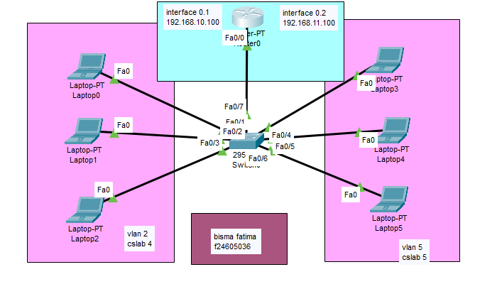
Figure 1. Packet Tracer Topology Diagram

Configuration DHCP for Inter-Vlan by Using Router
Step1: Configure switch for Vlan
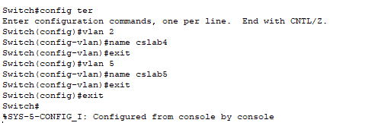
Step2: After creating Vlan connect a router to switch through fast Ethernet interface
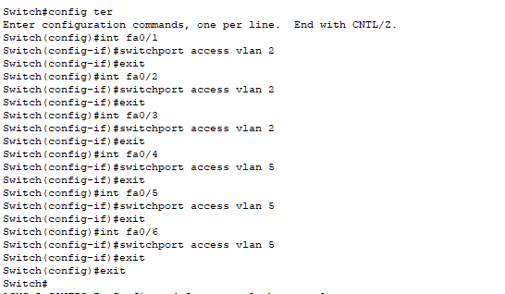
Switch configuration for Vlan
- en
- Config t
- Int fa0/7(switch interface connected with router)
- Switchport mode trunk
- Exit
- Exit
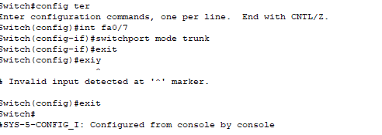
Step3: Router configuration for Vlan
- en
- Show ip interface brief
- Config t
- Int fa0/0(router interface connected with switch)
- No shutdown
- Exit
- Exit
- Show ip interface brief
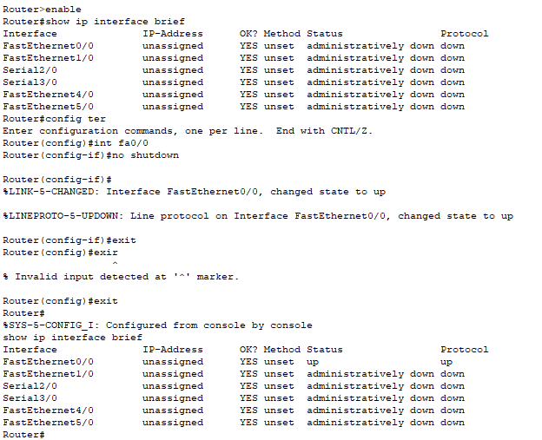

Creation of sub Interface and route
- en
- Show ip interface brief
- Config t
- Int fa0/0.1 (router interface connected with switch)
- Encapsulation dot1Q 2
- Ip address 192.168.10.100 255.255.255.0
- Exit
- Int fa0/0.2 (router interface connected with switch)
- Encapsulation dot1Q 5
- Ip address 192.168.11.100 255.255.255.0
- Exit
- Exit
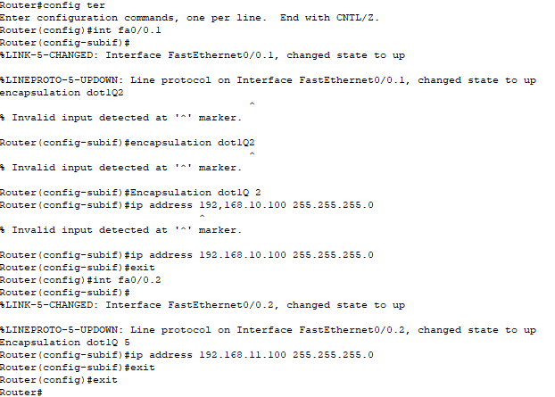

Step4: DHCP configuration in router
- en
- Config t
- Ip dhcp pool 1
- Network 192.168.10.0 255.255.255.0
- Default-router 192.168.10.100
- Exit
- Ip dhcp excluded-address 192.168.10.100 192.168.10.105
- Exit
- Repeat step 4 for other networks
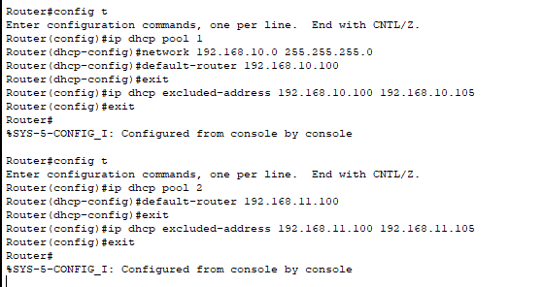
Realtime :
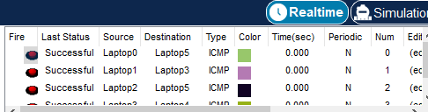
TASK 2
Draw given topology diagrams and attach screen shots of Pcs communication
- Highlight different sections
- Divide given topology in four different networks
- Ping different VLANs laptops.
- Send packets (Real time).
- Send packets(Simulation).
- Take screen shots of every step
Note*
All screen shots and topology labeling must be clearly visible.

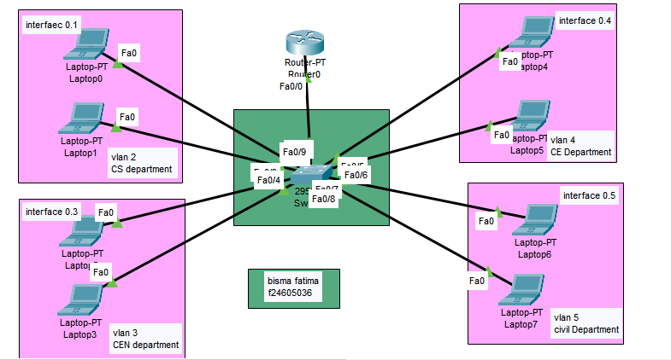
Figure 2. Task 2 topology diagram

Step1: Configure switch for Vlan
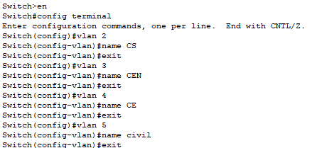
Step2: After creating Vlan connect a router to switch through fast Ethernet interface
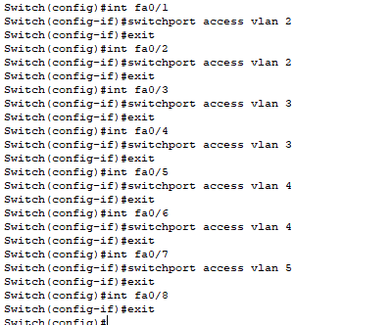
Switch configuration for Vlan
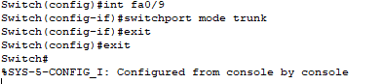
Step3: Router configuration for Vlan

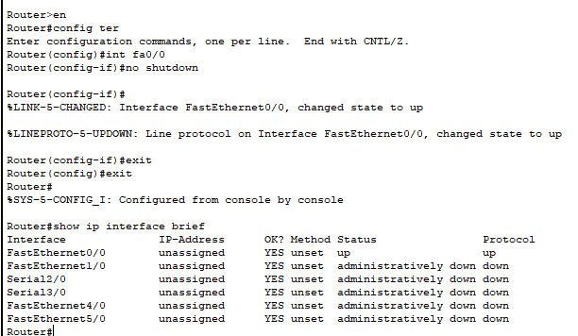
Creation of sub Interface and route

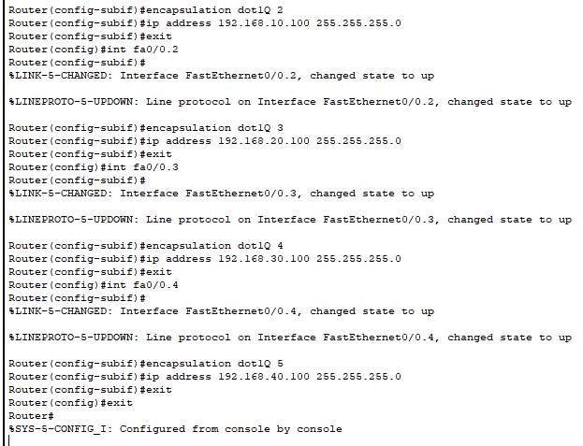
Step4: DHCP configuration in router

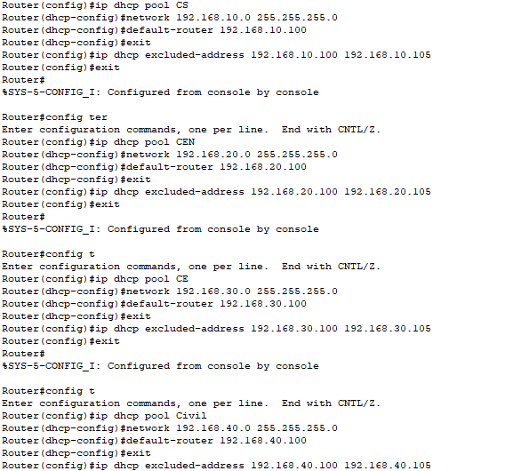
Show ip interface brief:
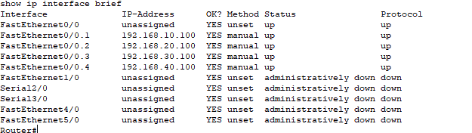

Pinging:
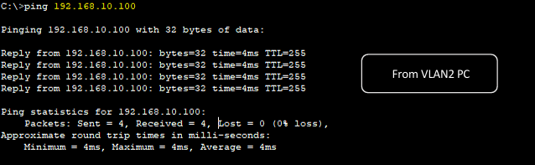

Real time:
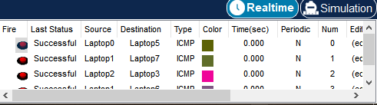

VLAN brief:
